CASE STUDY-1
OYO Business
SQL_Query:

CREATE DATABASE oyo_city;
USE oyo_city;

oyo_sales.sql :
CREATE TABLE oyo_sales (
booking_id INT PRIMARY KEY,
customer_id INT,
status VARCHAR(20),
check_in DATE,
check_out DATE,
no_of_rooms INT,
hotel_id INT,
amount INT,
discount INT,
date_of_booking DATE
);

INSERT INTO oyo_sales VALUES (170, 9197, 'Cancelled', '2022-01-14', '2022-01-15', 1, 757, 3137, 796, '2022-01-01');
INSERT INTO oyo_sales VALUES (171, 9197, 'Cancelled', '2022-01-16', '2022-01-17', 1, 757, 3137, 663, '2022-01-01');
INSERT INTO oyo_sales VALUES (583, 11659, 'Stayed', '2022-01-01', '2022-01-02', 2, 16, 6237, 1320, '2022-01-01');
INSERT INTO oyo_sales VALUES (642, 14499, 'Cancelled', '2022-01-16', '2022-01-18', 10, 346, 59254, 12535, '2022-01-01');
INSERT INTO oyo_sales VALUES (569, 15037, 'No Show', '2022-01-02', '2022-01-03', 1, 207, 1884, 398, '2022-01-01');
INSERT INTO oyo_sales VALUES (882, 22257, 'Cancelled', '2022-01-01', '2022-01-02', 1, 800, 3444, 875, '2022-01-01');
INSERT INTO oyo_sales VALUES (419, 29124, 'Cancelled', '2022-01-02', '2022-01-03', 1, 380, 2144, 453, '2022-01-01');
INSERT INTO oyo_sales VALUES (436, 33021, 'No Show', '2022-01-01', '2022-01-02', 1, 62, 2252, 476, '2022-01-01');
INSERT INTO oyo_sales VALUES (889, 65208, 'Stayed', '2022-01-01', '2022-01-02', 1, 117, 5589, 1419, '2022-01-01');
INSERT INTO oyo_sales VALUES (17, 66762, 'Stayed', '2022-01-07', '2022-01-08', 1, 109, 3509, 743, '2022-01-01');
INSERT INTO oyo_sales VALUES (153, 77179, 'Stayed', '2022-01-02', '2022-01-06', 1, 106, 11887, 2515, '2022-01-01');
INSERT INTO oyo_sales VALUES (545, 81709, 'Cancelled', '2022-01-02', '2022-01-03', 1, 449, 2192, 464, '2022-01-01');
INSERT INTO oyo_sales VALUES (416, 86098, 'Stayed', '2022-01-01', '2022-01-02', 1, 579, 2599, 550, '2022-01-01');
INSERT INTO oyo_sales VALUES (641, 86311, 'Stayed', '2022-01-01', '2022-01-02', 1, 346, 3199, 677, '2022-01-01');
INSERT INTO oyo_sales VALUES (491, 102430, 'Cancelled', '2022-01-02', '2022-01-03', 1, 3, 2469, 523, '2022-01-01');
INSERT INTO oyo_sales VALUES (149, 112913, 'Stayed', '2022-01-29', '2022-02-02', 1, 409, 26255, 5554, '2022-01-01');
INSERT INTO oyo_sales VALUES (799, 118118, 'Stayed', '2022-01-01', '2022-01-02', 1, 689, 4224, 893, '2022-01-01');
INSERT INTO oyo_sales VALUES (445, 145486, 'No Show', '2022-01-03', '2022-01-04', 1, 378, 4939, 1045, '2022-01-01');
INSERT INTO oyo_sales VALUES (798, 159297, 'Cancelled', '2022-01-09', '2022-01-13', 1, 164, 14815, 3134, '2022-01-01');
INSERT INTO oyo_sales VALUES (895, 166300, 'Stayed', '2022-01-01', '2022-01-02', 1, 501, 5004, 1058, '2022-01-01');
INSERT INTO oyo_sales VALUES (731, 168983, 'Cancelled', '2022-01-01', '2022-01-02', 1, 417, 2201, 465, '2022-01-01');
INSERT INTO oyo_sales VALUES (856, 169224, 'Cancelled', '2022-01-08', '2022-01-09', 1, 136, 5654, 1436, '2022-01-01');
INSERT INTO oyo_sales VALUES (568, 182041, 'No Show', '2022-01-02', '2022-01-03', 1, 207, 1884, 398, '2022-01-01');
INSERT INTO oyo_sales VALUES (283, 184360, 'Cancelled', '2022-01-02', '2022-01-03', 1, 473, 2989, 759, '2022-01-01');
INSERT INTO oyo_sales VALUES (519, 189769, 'Stayed', '2022-01-01', '2022-01-02', 1, 420, 2469, 523, '2022-01-01');
INSERT INTO oyo_sales VALUES (570, 196020, 'Cancelled', '2022-01-01', '2022-01-02', 1, 207, 2339, 495, '2022-01-01');
INSERT INTO oyo_sales VALUES (624, 1864, 'Stayed', '2022-01-02', '2022-01-03', 1, 653, 2534, 536, '2022-01-02');
INSERT INTO oyo_sales VALUES (738, 26536, 'Stayed', '2022-01-09', '2022-01-13', 1, 365, 6235, 0, '2022-01-02');
INSERT INTO oyo_sales VALUES (808, 38803, 'Stayed', '2022-01-05', '2022-01-06', 1, 628, 2597, 550, '2022-01-02');
INSERT INTO oyo_sales VALUES (859, 44047, 'Stayed', '2022-01-03', '2022-01-07', 1, 804, 17155, 3629, '2022-01-02');
INSERT INTO oyo_sales VALUES (516, 44356, 'Stayed', '2022-01-02', '2022-01-03', 1, 33, 2079, 440, '2022-01-02');
INSERT INTO oyo_sales VALUES (657, 45644, 'Stayed', '2022-01-02', '2022-01-04', 1, 50, 4807, 1018, '2022-01-02');
INSERT INTO oyo_sales VALUES (977, 56694, 'Cancelled', '2022-01-02', '2022-01-03', 1, 777, 2794, 591, '2022-01-02');
INSERT INTO oyo_sales VALUES (786, 57879, 'Cancelled', '2022-01-03', '2022-01-04', 1, 808, 2794, 710, '2022-01-02');
INSERT INTO oyo_sales VALUES (83, 68240, 'Stayed', '2022-01-02', '2022-01-03', 1, 245, 2005, 425, '2022-01-02');
INSERT INTO oyo_sales VALUES (312, 88939, 'Stayed', '2022-01-02', '2022-01-03', 1, 570, 3769, 798, '2022-01-02');
INSERT INTO oyo_sales VALUES (314, 88939, 'Stayed', '2022-01-03', '2022-01-04', 1, 570, 3509, 891, '2022-01-02');
INSERT INTO oyo_sales VALUES (704, 106977, 'Cancelled', '2022-01-04', '2022-01-05', 1, 58, 2534, 644, '2022-01-02');
INSERT INTO oyo_sales VALUES (109, 108129, 'Stayed', '2022-01-02', '2022-01-03', 1, 938, 2469, 523, '2022-01-02');
INSERT INTO oyo_sales VALUES (846, 120340, 'Stayed', '2022-01-03', '2022-01-04', 1, 330, 6824, 1502, '2022-01-02');
INSERT INTO oyo_sales VALUES (31, 120371, 'Stayed', '2022-01-02', '2022-01-03', 1, 755, 3184, 809, '2022-01-02');
INSERT INTO oyo_sales VALUES (809, 121394, 'Stayed', '2022-01-03', '2022-01-05', 1, 628, 3726, 789, '2022-01-02');
INSERT INTO oyo_sales VALUES (379, 124801, 'Cancelled', '2022-01-02', '2022-01-03', 1, 716, 3379, 858, '2022-01-02');
INSERT INTO oyo_sales VALUES (434, 126821, 'Stayed', '2022-01-03', '2022-01-04', 2, 62, 5327, 1352, '2022-01-02');
INSERT INTO oyo_sales VALUES (435, 126821, 'Stayed', '2022-01-03', '2022-01-04', 1, 62, 2664, 677, '2022-01-02');
INSERT INTO oyo_sales VALUES (391, 130118, 'No Show', '2022-01-15', '2022-01-16', 1, 147, 4029, 853, '2022-01-02');
INSERT INTO oyo_sales VALUES (433, 136431, 'Stayed', '2022-01-02', '2022-01-03', 1, 62, 2794, 591, '2022-01-02');
INSERT INTO oyo_sales VALUES (41, 145504, 'Stayed', '2022-01-03', '2022-01-05', 1, 232, 3510, 891, '2022-01-02');
INSERT INTO oyo_sales VALUES (763, 150171, 'Cancelled', '2022-01-02', '2022-01-03', 1, 655, 3509, 743, '2022-01-02');
INSERT INTO oyo_sales VALUES (18, 161206, 'Stayed', '2022-01-03', '2022-01-04', 1, 109, 2859, 605, '2022-01-02');
INSERT INTO oyo_sales VALUES (418, 161755, 'Cancelled', '2022-01-02', '2022-01-03', 1, 380, 1949, 495, '2022-01-02');

oyo_city.sql :
CREATE TABLE oyo_city (
hotel_id INT PRIMARY KEY,
city VARCHAR(50)
);

INSERT INTO oyo_city (hotel_id, city) VALUES
(3, 'Gurgaon'),
(13, 'Gurgaon'),
(16, 'Gurgaon'),
(21, 'Gurgaon'),
(25, 'Delhi'),
(29, 'Gurgaon'),
(31, 'Delhi'),
(33, 'Gurgaon'),
(37, 'Gurgaon'),
(44, 'Noida'),
(45, 'Delhi'),
(48, 'Delhi'),
(49, 'Delhi'),
(50, 'Gurgaon'),
(56, 'Bangalore'),
(58, 'Gurgaon'),
(59, 'Noida'),
(62, 'Delhi'),
(68, 'Mumbai'),
(69, 'Noida'),
(73, 'Delhi'),
(74, 'Gurgaon'),
(77, 'Gurgaon'),
(81, 'Delhi'),
(83, 'Bangalore'),
(84, 'Bangalore'),
(86, 'Bangalore'),
(88, 'Bangalore'),
(89, 'Delhi'),
(91, 'Delhi'),
(92, 'Delhi'),
(93, 'Delhi'),
(96, 'Mumbai'),
(99, 'Delhi'),
(106, 'Bangalore'),
(107, 'Bangalore'),
(109, 'Bangalore'),
(111, 'Mumbai'),
(114, 'Delhi'),
(116, 'Gurgaon'),
(117, 'Mumbai'),
(123, 'Jaipur'),
(124, 'Jaipur'),
(128, 'Bangalore'),
(129, 'Delhi'),
(130, 'Delhi'),
(131, 'Gurgaon'),
(132, 'Delhi'),
(135, 'Delhi'),
(136, 'Mumbai'),
(139, 'Jaipur');

-- 1. Find the - average room rates of different cities
SELECT
c.city,
ROUND(AVG(CAST(s.amount AS FLOAT) / NULLIF(s.no_of_rooms, 0)), 2) AS avg_room_rate
FROM oyo_sales s
JOIN oyo_city c ON s.hotel_id = c.hotel_id
GROUP BY c.city;

Output:
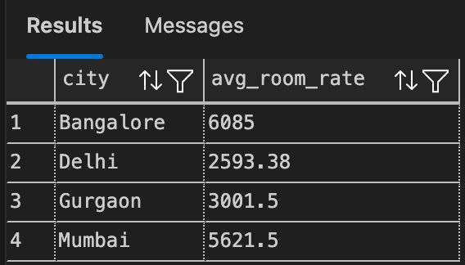

-- 2. Find the - No of bookings of different cities in Jan Feb Mar Months.
SELECT
c.city,
DATENAME(MONTH, s.date_of_booking) AS booking_month,
COUNT(*) AS no_of_bookings
FROM oyo_sales s
JOIN oyo_city c ON s.hotel_id = c.hotel_id
WHERE MONTH(s.date_of_booking) IN (1, 2, 3)
GROUP BY c.city, DATENAME(MONTH, s.date_of_booking)
ORDER BY c.city, booking_month;

Output:
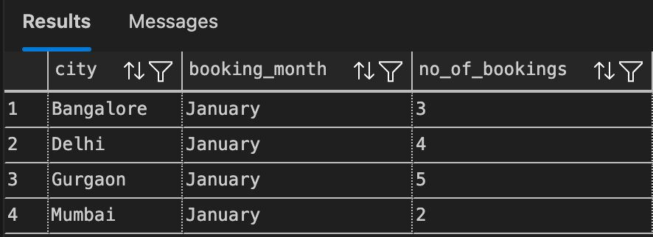

-- 3. Write a sql query for the -- Frequency of early bookings prior to check-in the hotel
SELECT
DATEDIFF(DAY, s.date_of_booking, s.check_in) AS days_prior,
COUNT(*) AS frequency
FROM oyo_sales s
WHERE DATEDIFF(DAY, s.date_of_booking, s.check_in) >= 0
GROUP BY DATEDIFF(DAY, s.date_of_booking, s.check_in)
ORDER BY days_prior;

Output:
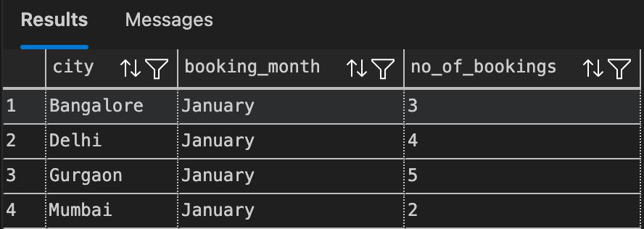

-- 4. write the sql query Frequency of bookings of no of rooms in Hotel
SELECT
no_of_rooms,
COUNT(*) AS frequency
FROM oyo_sales
GROUP BY no_of_rooms
ORDER BY no_of_rooms;

Output:
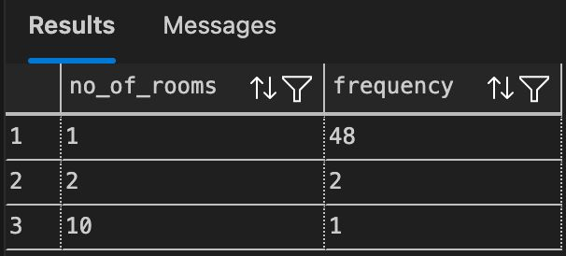

-- 5. write the sql query-- NEW CUSTOMERS ON JAN MONTH
SELECT
customer_id,
MIN(date_of_booking) AS first_booking_date
FROM oyo_sales
GROUP BY customer_id
HAVING MONTH(MIN(date_of_booking)) = 1;

Output:
